**Empower HR: Unveiling the Secrets of Attrition and Training Efficacy**

**Introduction:**

This report aims to provide insights into two key aspects of human resource management: employee attrition and training program effectiveness. The analysis is based on HR data that includes various metrics like age, department, performance ratings, and more.

**Objectives:**

The project focuses on two primary objectives:

1. To determine the factors contributing to employee attrition and provide insights for reducing attrition rates.
2. To analyze the effectiveness of training programs and recommend improvements.

**Data Cleaning and Preparation:**

The initial dataset contained several missing values and discrepancies. Data cleaning involved:

1. For the Gender & Position column, the values were updated to a more concise format for easier handling in future analyses. Specifically, the transformations were:
   1. 'Female' was replaced with 'F'
   2. 'Male' was replaced with 'M
   3. 'DataScientist' was replaced with 'Data Scientist'
   4. 'Marketinganalyst' was replaced with 'Marketing Analyst'
2. For the purpose of more detailed analysis, the Age and Salary columns were categorized into different groups. These categorizations were designed to facilitate subgroup analyses, enabling the identification of patterns or trends that might not be obvious when considering the entire data set.
   1. Age Categories:
      1. Less than or equal to 30 years
      2. Greater than 30 years
   2. Salary Categories:
      1. 50K - 60K
      2. 60K - 70K
      3. 70K - 80K
      4. 80K - 90K
      5. 90K - 100K
3. Converting the Last Promotion Date to a standard date format.

**Analysis and Insights:**

**Employee Attrition Analysis:**

1. **Department-wise attrition rates**

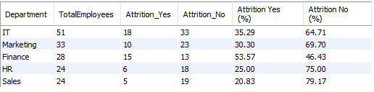

* The Finance department has the highest attrition rate at 53.57%, followed by IT at 35.29%.
* The Sales department has the lowest attrition rate at 20.83%.

1. **Position-wise attrition rates**

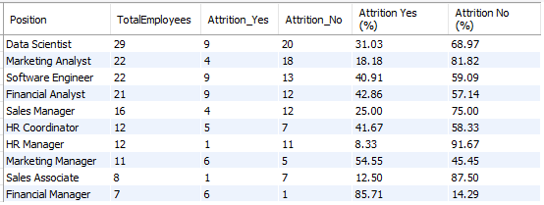

* The positions with the highest attrition rates are Financial Manager (85.71%) and Marketing Manager (54.55%). Immediate attention is needed to understand why these roles are experiencing such high attrition.
* The HR Manager position has the lowest attrition rate at 8.33%, followed by the Sales Associate at 12.50%. These roles seem to have higher job stability.
* Roles like Software Engineer and Financial Analyst have nearly equal proportions of attrition, indicating that the reasons for leaving could be multifactorial and require a deeper dive.
* While Data Scientists have a 31.03% attrition rate, the total number of Data Scientists is the highest at 29. Even if the rate is not the highest, the volume of attrition could be impactful.
* Interestingly, the HR Coordinator has a higher attrition rate (41.67%) compared to the HR Manager (8.33%), suggesting that the level in the hierarchy could be a factor in job stability.
* The Marketing Analyst has a lower attrition rate compared to the Marketing Manager. This might indicate that as employees move up the ladder in Marketing, they are more likely to leave.

1. **Performance rating-wise attrition rates**

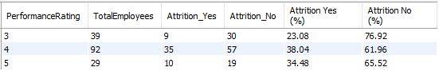

* Employees with a performance rating of 4.0 have the highest attrition rate at 38.04%.
* Even employees with a high-performance rating of 5.0 have a significant attrition rate of 34.48%.
* Employees with a performance rating of 3.0 have the lowest attrition rate at 23.08%.
* It's intriguing that employees with higher performance ratings are more likely to leave the company.

1. **Years of Service-wise attrition rates**

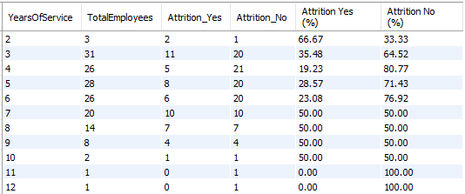

* Employees with 2 years of service have a very high attrition rate of 66.67%. This suggests that newer employees are more likely to leave, possibly due to inadequate onboarding or mismatched job expectations.
* After the initial 2 years, the attrition rate drops but peaks again for employees with 7 to 10 years of service. This could be the 'mid-career crisis' point where employees look for more fulfilling roles or better opportunities elsewhere.
* Employees at 7, 8, 9, and 10 years appear to be at high risk of leaving, each with a 50% attrition rate. Special attention should be given to employees reaching these milestones.
* The attrition rate varies significantly across different years of service, indicating that a same retention strategy is unlikely to be effective.

1. **Satisfaction Score-wise attrition rates**

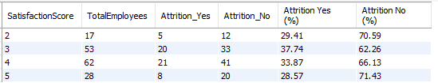

* Employees with a satisfaction score of 3 have the highest attrition rate at 37.74%.
* Interestingly, even those with a high satisfaction score of 4 have an attrition rate of 33.87%.
* Employees with the highest satisfaction score of 5 have the lowest attrition rate, but it's still a significant 28.57%.

1. **Salary-wise attrition rates**

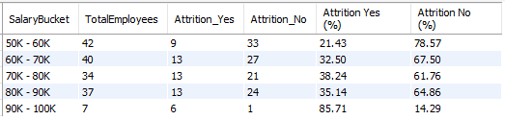

* The 90K - 100K salary bucket shows an alarmingly high attrition rate of 85.71%. This is particularly concerning as these employees are likely to be in more senior or specialized roles where attrition can be especially costly for the company.
* There seems to be a general trend that higher salaries correlate with higher attrition rates (from 21.43% in the 50K-60K range to 85.71% in the 90K-100K range). This is counterintuitive and suggests that factors other than salary may be driving employees to leave.
* Employees in the 50K - 60K range seem to be the most stable, with an attrition rate of only 21.43%. This could suggest that employees in this range find the compensation satisfactory for their role, or it could be that other factors like job security are more important to them.

1. **Relationship between Years of Service x Promotion**

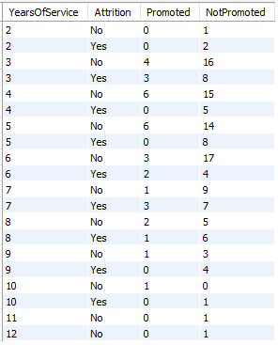

* Employees with 2 years of service neither get promoted nor do they stay, suggesting that they may leave due to lack of growth opportunities.
* For the 4th and 5th years, it's interesting to note that none of the employees who left were promoted. This could imply that lack of promotion may be a factor in attrition.
* In the 7th and 8th years, some employees were promoted but still left, indicating that promotion is not the only factor affecting attrition.

1. **Overall Comparison**



1. The attrition rate for all employees is 33.75%, which is quite high and warrants immediate attention.
2. Employees who left the company have a higher average salary (70,907) compared to those who stayed (66,094). This is counterintuitive and suggests that salary alone may not be a significant retention factor.
3. The average age of employees who left is slightly higher (31) than those who stayed (30), although the difference is not significant.
4. Employees who left have a slightly higher average years of service (6) compared to those who stayed (5). This may indicate that employees may be leaving around a 'mid-career' point, possibly looking for better opportunities or career growth.
5. The average satisfaction score is 4 for both groups, which is surprising. This suggests that job satisfaction scores may not be a reliable indicator for predicting attrition.
6. Employees who left have a slightly higher average work hours per week (43) compared to those who stayed (40). This could indicate that work-life balance might be a concern for those who left.
7. Interestingly, the average training hours are higher for employees who stayed (21) than for those who left (19).

**Effectiveness of Training programs:**

1. **Training Hours x Avg. Performance rating**

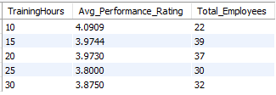

* Employees with only 10 hours of training have the highest average performance rating of 4.09. This is intriguing because it suggests that a lower amount of training is not necessarily detrimental to performance.
* There doesn't seem to be a direct correlation between the number of training hours and the average performance rating. For instance, 25 hours of training results in a lower average performance rating (3.80) compared to just 10 hours of training (4.09).
* Given that performance ratings don't linearly increase with more training, it's likely that the quality of the training content or its relevance to the job role may be more important factors affecting performance.

1. **Training Hours x Promotion**

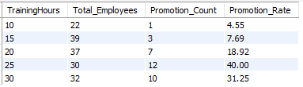

* There's a noticeable increase in the promotion rate as the training hours increase, peaking at 40% for those with 25 hours of training. This suggests that more extensive training is associated with higher chances of promotion.
* Employees with only 10 hours of training have the lowest promotion rate at 4.55%. This could imply that minimal training is not sufficient for career progression within the organization.

**Recommendations**

* Given the high attrition rates in the Finance and IT departments, targeted retention programs may be effective. This could include mentorship programs, work-life balance initiatives, and career development plans.
* Employees with 2 years and those with 7-10 years of service are leaving at high rates. For newer employees, improved onboarding and mentorship could help. For veterans, new career growth opportunities or skill diversification may be beneficial.
* Surprisingly, employees in higher salary brackets are leaving more frequently. This could indicate that the issue is not salary but other factors like work culture, growth opportunities, or job satisfaction. A comprehensive review could help understand this counterintuitive trend.
* Employees with higher performance ratings are also leaving. Ensure that high performers are adequately recognized and have clear paths for career progression.
* While job satisfaction is generally high, employees are still leaving. Regular surveys and one-on-one meetings could help identify and address hidden issues.
* The average training hours are lower for employees who left. This could point to the effectiveness of training programs for employee retention, although the difference is minimal.
* The number of training hours doesn't necessarily correlate with better performance. The focus should be on the quality and relevance of the training programs.
* Recommendations include focusing on training quality, tailoring training programs, and linking training to career progression.